**How to print filename with awk on Linux / Unix**

would like to print filename with awk on Linux / Unix-like system. How do I print filename in BEGIN section of awk? Can I print the name of the current input file using gawk/awk?  
  
The name of the current input file set in FILENAME variable. You can use FILENAME to display or print current input file name If no files are specified on the command line, the value of FILENAME is “-” (stdin). However, FILENAME is undefined inside the BEGIN rule unless set by getline.

**How to print filename with awk**

The syntax is:  
awk '{ print FILENAME }' fileNameHere  
awk '{ print FILENAME }' /etc/hosts  
You might see file name multiple times as awk read file line-by-line. To avoid this problem update your awk/gawk syntax as follows:  
awk 'FNR == 1{ print FILENAME } ' /etc/passwd  
awk 'FNR == 1{ print FILENAME } ' /etc/hosts  
[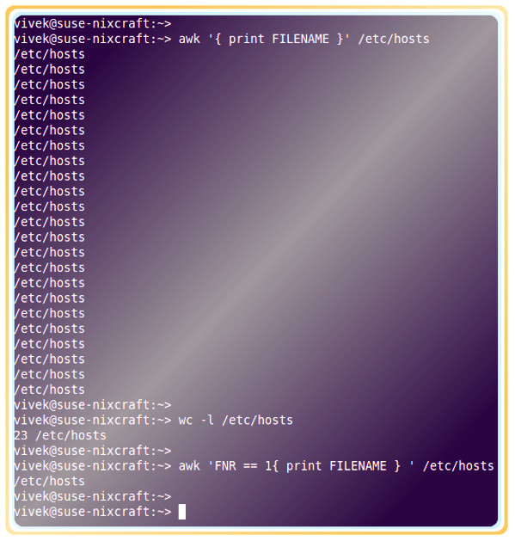](https://www.cyberciti.biz/media/new/faq/2018/02/How-to-print-filename-using-awk-on-Linux-or-Unix.jpg)

**How to print filename in BEGIN section of awk**

Use the following syntax:  
awk 'BEGIN{print ARGV[1]}' fileNameHere  
awk 'BEGIN{print ARGV[1]}{ print "someting or do something on data" }END{}' fileNameHere  
awk 'BEGIN{print ARGV[1]}' /etc/hosts  
Sample outputs:

/etc/hosts

However, ARGV[1] might not always work. For example:  
ls -l /etc/hosts | awk 'BEGIN{print ARGV[1]} { print }'  
So you need to modify it as follows (assuming that ls -l only produced a single line of output):  
ls -l /etc/hosts | awk '{ print "File: " $9 ", Owner:" $3 ", Group: " $4 }'  
Sample outputs:

File: /etc/hosts, Owner:root, Group: roo

**How to deal with multiple filenames specified by a wild card**

Use the following simple syntax:  
awk '{ print FILENAME; nextfile } ' *.c  
awk 'BEGIN{ print "Starting..."} { print FILENAME; nextfile }END{ print "....DONE"} ' *.conf  
Sample outputs:

Starting...

blkid.conf

cryptconfig.conf

dhclient6.conf

dhclient.conf

dracut.conf

gai.conf

gnome_defaults.conf

host.conf

idmapd.conf

idnalias.conf

idn.conf

insserv.conf

iscsid.conf

krb5.conf

ld.so.conf

logrotate.conf

mke2fs.conf

mtools.conf

netscsid.conf

nfsmount.conf

nscd.conf

nsswitch.conf

openct.conf

opensc.conf

request-key.conf

resolv.conf

rsyncd.conf

sensors3.conf

slp.conf

smartd.conf

sysctl.conf

vconsole.conf

warnquota.conf

wodim.conf

xattr.conf

xinetd.conf

yp.conf

....DONE

nextfile tells awk to stop processing the current input file. The next input record read comes from the next input file. For more information see awk/[gawk](https://www.gnu.org/software/gawk/manual/) command man page:  
man awk  
man gawk